**HelloWorld**

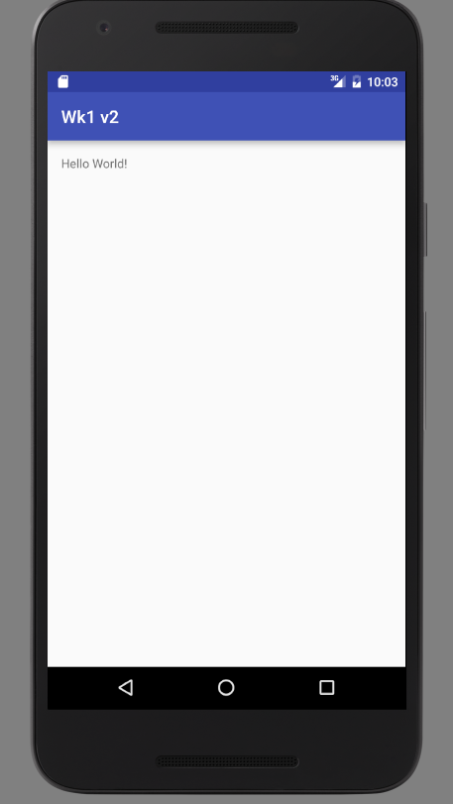

Opdracht 1

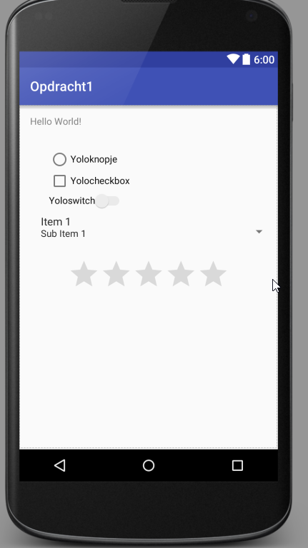

Links:

https://developer.android.com/guide/topics/ui/controls/checkbox.html

https://developer.android.com/guide/topics/ui/controls/radiobutton.html

https://developer.android.com/guide/topics/ui/controls/togglebutton.html

https://developer.android.com/reference/android/widget/RatingBar.html